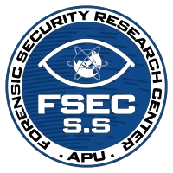

**Forensics Security Research Center Student Society**

**Asia Pacific University**

Presents:

**ParsEVTX: Simplifying EVTX Analysis**

**Technologies Covered:**

EvtxECmd & Timeline Explorer

**Host:**

Eric Hendryani

*Challenge Creator*

# 

# **Installation Guide**

## EvtxECmd

Go to this page: <https://ericzimmerman.github.io/#!index.md>



Download “EvtxECmd” version 1.5.1 (the first one) or just click [here](https://download.ericzimmermanstools.com/EvtxECmd.zip) to directly download it.

## Timeline Explorer

Same steps with the first one but instead of looking for EvtxECmd, look for “Timeline Explorer” download version 2.1.0



Click [here](https://download.ericzimmermanstools.com/net9/TimelineExplorer.zip) to download it directly.

After you have downloaded both files, you should have these ready **prior** to the workshop:



**See you there!**